**Water quality optimizer**

**Team Leader：**

Longfei Ke

**Submission Name:**

Water quality optimizer

**Short Description:**

Provide intelligent water resource scheduling solutions for water quality issues

**Long Description：**

At least 2 billion people rely on drinking water sources contaminated with fecal matter, posing a severe threat to both food safety and security. Despite the gravity of the situation, many regions grappling with water quality challenges continue to face with a lack of information and technology, impeding efficient protection and utilization of their water resources.

To address this issue, we propose the implementation of a comprehensive water quality management system-Global Water Quality Forecasting System. It can share water quality information around the world, provide local water quality prediction and solutions. It can also serve as a platform for communication and assistance on water quality issues. After logging into the system, the user selects water quality prediction, searches for regions, and the system uses IBM to process water quality data to generate water quality prediction results for the region. The results include detailed prediction values of various water quality parameters, various classification standards, evaluation, overall evaluation and so on. At the same time, Outlier of water quality prediction results will be highlighted. The user can click to generate a water quality optimization plan or seek help on the information platform.

When users click to generate a water quality optimization plan for a certain area, the system will generate a general plan to solve a certain type of abnormality, and list the relevant policy support in this area. In addition, the system will recommend successful cases of solving such problems for users to refer to.

We have also established a communication channel. Users can publicly disclose regional water quality information on the information platform and seek assistance, so that the platform has formation on solved and pending water quality issues around the world. Users can filter based on regions, types, and other conditions. Information is available here for any person or organization who wants to help with water quality issues.

**Solution roadmap:**

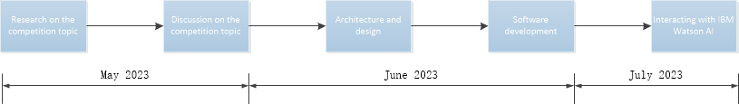

**Link to publicly accessible GitHub repository：**

<https://github.com/feicunkebei/Call-for-code>

**Link to a three-minute demo video:**

<https://www.youtube.com/watch?v=56ektD1wWUU>

**List one or more IBM Cloud Services or IBM Systems used in the solution:**

IBM Watson studio